**YAML**

* YAML is a data represntation language.
* YAML is name value pair collection
* YAML represents name value pair as <name>: <value>
* names generally are strings/text and value can be of any type
* Types:
  + Simple
    - Text/String
    - number
    - boolean
  + Complex
    - list
    - object/map
* Generally yaml used for some configuration purposes will have predefined structure/schema
* Resume

---

career_objective: <type text>

professional_summary: <type text>

technical skills: <type TechicalSkill>

WorkExperience: <type WorkExperience Array>

contact: <type Contact>

TechicalSkill: <type Skill Array>

Skill =>

<name of skill>: <type text Array>

WorkExperience =>

Company: <type text>

StartDate: <type text>

EndDate: <type text>

RolesAndResponsibilities: <type text Array>

Designation: <type text>

Contact =>

email: <type text>

phone: <type text>

Let’s start writing a resume based on schema defined above

---

career_objective: |

Seeking a challenging position in a reputed organization where

I can learn new skills, expand my knowledge, and leverage my

learnings

professional_summary: |

Skilled DevOps Engineer with 3+ years of hands-on experience

supporting, automating, and optimizing mission critical

deployments in AWS, leveraging configuration management, CI/CD,

and DevOps processes. &nbsp; Configuration management using

Puppet, Ansible, and Chef. Knowledge of Python, C/C++

technicalskills:

- os:

- linux

- windows

- ci/cd:

- Jenkins

- Azure DevOps

- VCS:

- git

WorkExperience:

- Company: Apple

StartDate: 6/25/2020

EndDate: Present

RolesAndResponsibilities:

- Maintaining CI/CD Pipelines

- Developing K8s Manifests

Designation: Sr DevOps Engineer

- Company: Google

StartDate: 6/25/2014

EndDate: 6/24/2017

RolesAndResponsibilities:

- Maintaining CI/CD Pipelines

- Developing K8s Manifests

Designation: DevOps Engineer

Let’s look at one more schema for describing investments

---

realestate: <type Property Array>

Equity: <type Equity Array>

MF: <type MF Array>

FD: <type FD Array>

Property =>

AssetValue: <type Number>

Type: <type Text> Commercial|Residential|Agricultural

AreaInSqft: <type Number>

Equity =>

Company: <type text>

NumberOfStocks: <type number>

StockIndex: <type text> NSE|BSE|DOW

AverageStockPrice: <type number>

MF =>

Instrument: <type text>

Number: <type number>

AveragePrice: <type number>

FD =>

Bank: <type Text>

Amount: <type Number>

IntrestRate: <type Number>

Sample YAML

realestate:

- AssetValue: 100000000

Type: Commercial

AreaInSqft: 3000

Equity:

- Company: HUL

NumberOfStocks: 1000

StockIndex: NSE

AverageStockPrice: 100.5

- Company: ITC

NumberOfStocks: 10000

StockIndex: NSE

AverageStockPrice: 10.5

MF:

- Instrument: SBI Magnum Small Cap

Number: 100000

AveragePrice: 350.4

FD:

- Bank: Sapthagiri Grameena Bank

Amount: 10000000000

IntrestRate: 9.75

**Azure DevOps Pipeline**

* Azure DevOps Pipelines are expressed in yaml formats in git repositories generally with name azure-pipelines.yaml  
  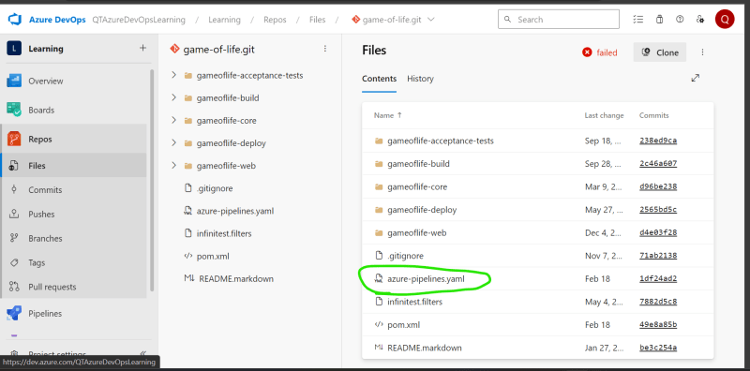
* YAML Schema for azure devops pipelines <https://learn.microsoft.com/en-us/azure/devops/pipelines/yaml-schema/?view=azure-pipelines>
* Key Concepts of Azure DevOps <https://learn.microsoft.com/en-us/azure/devops/pipelines/get-started/key-pipelines-concepts?view=azure-devops>
* Pipeline:
  + Where should it execute? => Agents
  + When should it run => Trigger
  + What should happend when pipeline executes
    - Stages
    - Jobs
    - Steps
* When pipeline is executed, it is execute with code from version control already cloned and, in the branch, specified

---

trigger:

- master

pool: ubuntu-latest

stages:

- stage: stage1

displayName: first stage

jobs:

- job: build code

displayName: Build Code

steps:

- task: Maven@4

inputs:

mavenPOMFile: 'pom.xml'

goal: package

* If your pipeline has only one stage, consider pipeline is collection of jobs

Let’s try to write the same pipeline above as collection of jobs as we have only one stage

---

name: learning

trigger:

- master

pool: ubuntu-latest

jobs:

- job: buildjob

displayName: Build JOB

steps:

- task: Maven@4

inputs:

mavenPOMFile: 'pom.xml'

goal: 'package'

Let’s write the pipeline as collection of steps

---

name: learning

trigger:

- master

pool: ubuntu-latest

steps:

- task: Maven@4

inputs:

mavenPOMFile: 'pom.xml'

goal: 'package'